From the Diary of Anne Frank

By– Anne Frank

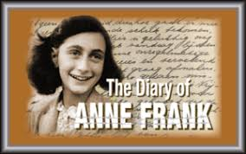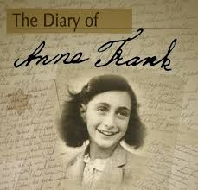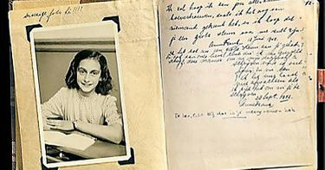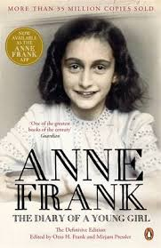

Anne Frank – A Short Biography

About the Authoress
Anne Frank (12 June 1929—February/March 1945) was a German Jew. The twelve-year-old Jewish girl wrote ‘The Diary of Anne Frank’ while in hiding with her family and four friends in Amsterdam during the Nazis’ occupation of the Netherlands in World War II. After two years in hiding, the group was betrayed and transported to a concentration camp in Bergen where Anne and her elder sister Margot died of typhus in 1945. Her father, Otto, the only survivor of the group found her diary and got it published in English under the name ‘The Diary of a Young Girl

Introduction of the lesson- From the Diary of Anne Frank
INTRODUCTION
Anne Frank was a young Jewish girl. She lived with her parents in Germany. But Hitler’s Nazi Party was against the Jews. The Nazis were killing the Jews or forcing them to work in the concentration camps. The Frank family fled from Germany in 1933 and took shelters in the Netherlands. But in 1940, Germany attacked the Netherlands and captured it. Now the Nazis started arresting the Jews and sending them to the concentration camps. The Frank family went into hiding. They lived secretly in the upper floors of their business premises. They hid there for 25 months. Their non-Jewish friends gave them food.
Anne had started writing her diary before going into hiding. In August 1944, the Germans came to know of their hiding. They were arrested and sent to Germany. Anne, her sister, Margot and her mother soon died in a concentration camp. Her father survived and published part of Anne’s diary. In this diary, Anne gives a moving and tragic account of the difficulties faced by her family and the other Jews. The part of the diary reproduced in this chapter is about the days when Anne was a schoolgirl and she and her family had not yet moved to the secret quarters. The Diary of Anne Frank’ and the given extract is one of the most authentic works describing the atrocities committed on the Jews during the Nazi’s occupation of the Netherlands in the 1940s. It also provides an intimate account of daily life that her small groups led in hiding in Amsterdam. Her frankness, honesty and sincerity of description of her parents, friends and teachers make her writing the most important document of the Holocaust period.

